{office_banner}
This is to certify that

{user_fullname}
participated in a Continuing Professional Development event entitled

{program_name}
CERT+ SESSION ID# {program_main_pro_plus_session_id}
on
{program_start_date} to {program_end_date}
at
{venue_name}, {venue_city}, {venue_province}
Credits for Family Medicine Specialists:
This 1-credit-per hour Group Learning program meets the certification criteria of the College of Family Physicians of Canada and has been certified by Queen's University for up to XX Mainpro+ credits. Session ID: XXXXXX
Credits for Royal College Specialists:
This event is an Accredited Group Learning Activity (Section 1) as defined by the Maintenance of Certification Program of The Royal College of Physicians and Surgeons of Canada, and approved by Queen's University CPD team. You may claim a maximum of XX hours (credits are automatically calculated).
Credits for Health Care Professionals:
This is a professional development learning activity which provides up to XX hours of continuing education.
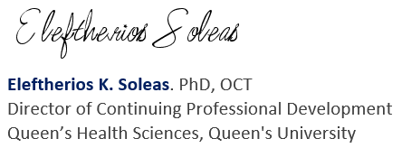
{office_name} {office_address}, {office_city}, {office_province},
{office_postal_code} Tel: {office_phone} Fax: {office_fax} Email: {office_email}
Website: {office_website}

